**Document A: Textbook Account, 2018** (Excerpted)

In the late 1300s, the Inca were only a small community in the area of Cuzco, a city located at 11,000 feet in the mountains of southern Peru. In the 1440s, however, under the leadership of the ruler Pachacuti, the Inca launched a campaign of conquest that eventually brought the entire region under Inca control. . . .

Pachacuti and his immediate successors, Topa Inca Yupanqui and Huayna Capac Inca—*Inca* means “ruler”—extended the boundaries of the Inca Empire as far as Ecuador, central Chile, and the edge of the Amazon basin. The empire included perhaps 12 million people.

The Inca state was built on war. All young men were required to serve in the Inca army. With some 200,000 members, the army was the largest and best armed in the region. . . .

After an area was placed under Inca control, the local inhabitants were instructed in the Quechua language. Control of new territories was carefully regulated. A noble of high rank was sent to govern the new region. Local leaders could keep their posts as long as they were loyal to the Inca ruler.

To encourage loyalty, the children of local leaders were taken as **hostages** to the Inca capital, where they were educated in Inca ways before returning home. . . .

Forced labor was another important feature of the state. All Inca subjects were responsible for labor service, usually for several weeks each year. Laborers, often with their entire communities, were moved according to need from one part of the country to another to take part in building projects.

**Source:** Spielvogel, Jackson J., and Jay McTighe, 2018. *World History and Geography*.

**Vocabulary**

hostage: a person held captive

**Document B: Pedro Sarmiento de Gamboa, 1572** (Modified)

*Pedro Sarmiento de Gamboa was a Spanish sea captain and royal scientist. The following excerpt is from his book The History of the Incas, completed in 1572.*

*Sarmiento wrote this book in Cusco on orders of the Spanish* ***viceroy*** *of Peru, near the end of the Spanish Conquest of the Inca Empire. The Inca preserved their history through oral histories and* **quipus***. Sarmiento carefully collected the data for his book by interviewing the surviving Inca nobility about their history. He wrote his account to argue that the Inca were not the rightful rulers of the Andes and that instead the Spanish were.*

THE NATIONS THAT PACHACUTI INCA DESTROYED AND THE TOWNS HE ATTACKED; FIRST, TOCAY CAPAC, THE RULER OF THE AYAMARCAS

Near the Cusco Valley is a nation of Indians called Ayarmacas who had a proud and wealthy ruler named Tocay Capac. Neither he nor the Ayarmacas wanted to **pay homage** to the Inca. Instead, they sought to ready their weapons against the Inca, in case they decided to turn against them. Knowing this, Pachacuti called an assembly of his people and their communities. He combined them into one body so that once together no one could or would fight against them. They decided to join together and leave to conquer all the nations of the kingdom, and those who did not give in to them or serve them of their own free will they would utterly destroy. And they decided that before anything else they should go against Tocay Capac, the ruler of the Ayarmacas, who was powerful and had not come to **pay homage** to the Inca. And with the warriors thus gathered, they went against the Ayarmacas and their ruler*,* and they fought each other in Guanancancha. Pachacuti defeated them, and he destroyed the towns and killed almost all of the Ayarmacas. He brought Tocay Capac as a captive to Cusco and kept him in prison until his death.

**Source:** Pedro Sarmiento de Gamboa, *The History of the Incas*, 1572.

**Vocabulary**

*quipu:* knotted strings used to store information

viceroy: an official who rules a colony on behalf of a monarch pay homage: show respect to an authority

# Document C: Felipe Guamán Poma de Ayala, 1615 (Modified)

*The following are excerpts from Felipe Guamán Poma de Ayala’s book* The First New Chronicle and Good Government*. Guamán Poma came from a noble Inca family in Peru. He hoped his history of the Incas and of the Spanish conquest would convince the king of Spain to make reforms in Peru. It’s unknown whether his book ever reached the king, but it serves as an invaluable source about life in the Andes.*

*Excerpt 1 is an illustration of the celebrations of the people of the Collasuyo (southern) quarter of the Inca Empire. The Inca held monthly celebrations in each town of their empire, in which food was given to the traveling workers who were fulfilling their mandatory labor tax to the empire. Workers who were especially productive would be recognized for their service.*

Excerpt 1

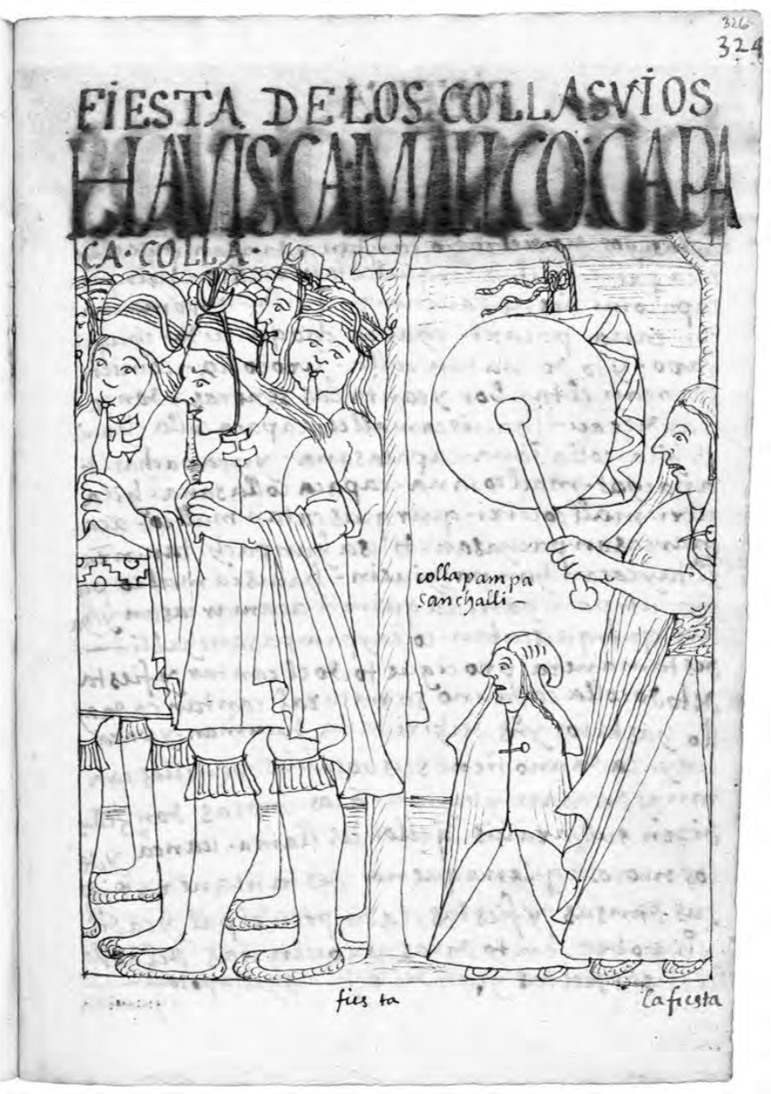

Excerpt 2

The tenth Inca, Topa Inca Yupanqui . . . was handsome, tall, very wise, and formal. He was at peace with and friends of the most important leaders. He liked festivals and banquets. He honored the important women. He was a great warrior. He hated liars; anyone who lied he would have killed. He was the one who ordered that all the royal roads and bridges be kept in good repair. He established the ***chasquis***. He ordered that there be royal officials, a sheriff, judges, president, a council of these kingdoms, an imperial official. He had a counselor, a deputy and protector, a secretary, the Inca’s ***quipu*** interpreter, accountant, a crime official, and he organized other offices. He spoke with the ***huacas*** every year He started

organizing his property and the community property and the food storehouses with much order, accounting and ***quipu*** officials throughout the kingdom.

Besides what his father took, he conquered half of Huanuco Allauca, Chinchaycocha, Tarma, all the mountain regions of Lima; Huno Huaylla, ten thousand Indians; Conchuco, Cajatambo.

**Source:** Felipe Guamán Poma de Ayala’s book *The First New Chronicle and Good Government,* 1615.

**Vocabulary**

*chasquis*: running messengers

*quipu*: knotted strings used to store information

*huaca*: a sacred space, mountain, or object in Andean culture

**Document D: Garcilaso de la Vega, 1609** (Modified)

*Garcilaso de la Vega was the son of a noble Inca woman and a Spanish conquistador. He was born in Cusco in 1539, during the Spanish conquest of the Inca Empire. He moved to Spain in 1560, when he was twenty-one, and never returned to Peru. The following is excerpted from his book* The Royal Commentaries of Peru*, which he published in 1609, about thirty-five years after the end of conquest of the Inca Empire.*

Though there have been learned Spaniards who have written about the republics of the New World, they have not described these kingdoms as fully as they might have done. I have noticed this particularly in things that I have seen written about Peru, about which, as a native of the city of Cusco, which was formerly the Rome of that empire, I have fuller and more accurate information than that provided by previous writers. For this reason, impelled by my natural love for my native country, I have undertaken the task of writing this book . . .

The Inca kings improved the Ica valley, which, like all these coastal valleys, became fertile, by building a very fine **canal** which brought down a great volume of water from high up in the mountains. In order to do this they very skillfully reversed the flow of the water, which had formerly run eastwards and was now made to flow westwards. Previously the Indians used to suffer greatly from drought in the maize fields, and many years, when it scarcely rained at all in the **sierra**, they lost their crops for lack of water. But now, with the aid of the canal, they more than doubled the extent of their **cultivable** land, and from then on lived in great abundance and prosperity. All this caused the conquered and unconquered Indians to desire and love the Inca empire, whose care and attention was, they observed, always devoted to providing such benefits in the valleys.

**Source:** *The Royal Commentaries of Peru*, Garcilaso de la Vega, 1609.

**Vocabulary**

canal: a constructed waterway sierra: a long mountain chain cultivable: able to use for farming

# Guiding Questions

**Document A: Textbook, 2018**

1. (Close Reading) Circle(I will highlight since on computer) all of the words that indicate the Inca expanded their empire through force. Underline all the words that indicate the Inca expanded their empire through ways other than force.
2. What is the main way the textbook suggests the Inca expanded their empire? Explain.

Through force of conquering a land

**Document B: Pedro Sarmiento de Gamboa, 1572**

1. (Sourcing) Who was Pedro Sarmiento de Gamboa?

He was a “*Spanish sea captain and royal scientist”*

Why did he write this document?

To tell that the “*Inca were not the rightful rulers of the Andes and that instead the Spanish were.”*

How might his reasons for writing this document have influenced what he wrote?

It might have influenced it by making him more critical towards the Inca.

1. (Close reading) According to this account, why did Pachacuti decide to attack the Ayarmacas?

Because the Ayarmacas did not want to “pay homage” to the inca.

1. (Contextualization) Pachacuti lived from 1418 to 1471 or 1472. Sarmiento wrote this account in 1572. How might this affect the reliability of his account? Explain.

It might have drastic differences depending how he got the information, it could be wrong because of the 100 year time gap, or it could be completely right based on if there were well kept records and one’s accessible.

1. (Contextualization) In the mid-1500s some Catholic priests criticized the Spanish government’s treatment of Native Americans. How might that context have influenced Sarmiento’s account?

It might have influenced it some or not at all, if he was informed enough and actually cared what priest said that it could have been the reason he wrote the excerpt.

1. (Corroboration) Does this account support or challenge the textbook’s account? Explain.

It supports it , the text book says that the Inca conquered the area which is the same basically as the account except that the account has more emotion.

**Document C: Felipe Guamán Poma de Ayala, 1615**

1. (Sourcing) Who was Guamán Poma de Ayala?

Why did he make this document?

How might his reasons for making this document have influenced his account?

1. (Close reading) Describe what you see in the illustration in Excerpt 1.

How does this illustration of the Inca state’s required labor system compare to the textbook’s account of the system?

1. (Close reading) How does Guamán Poma describe Topa Inca Yupanqui in Excerpt 2?
2. (Contextualization) Topa Inca Yupanqui lived from 1471 to 1493. Guamán Poma wrote this account in 1615. How might this affect the reliability of his account?
3. (Corroboration) Does this account support or challenge the textbook’s account? Explain.

**Document D: Garcilaso de la Vega, 1609**

1. (Sourcing) Who was Garcilaso de la Vega?

Why did he write this document?

How might his reasons for writing this document have influenced what he wrote?

1. (Close Reading) Circle all of the words that indicate the Inca expanded their empire through force. Underline all the words that indicate the Inca expanded their empire through ways other than force.
2. (Contextualization) The Inca expanded their empire mostly during the 15th century. De la Vega wrote this account in 1609. How might this affect the reliability of his account?
3. (Corroboration) Does this account support or challenge the textbook’s account? Explain.

*Write two paragraphs for a history textbook explaining how the Inca expanded their empire, using evidence from at least two of the historical documents (Documents B-D).*

**New Textbook Passage: How the Inca Expand Their Empire**